

***DATABASE OF STUDENT MANAGEMENT SYSTEM***

***NAME:*** *SYED FARAZ IBNE SALEEM, ALI KHURSHID, FAHAD SHAHZAD, TABARAK ZAHIR*

***ROLL:*** *241934, 241889, 241808, 241811*

***COURSE:*** *DATABASE SYSTEMS*

***INSTRUCTOR NAME:*** *Ms. ROMANA MAROOF*

***CLASS:*** *BSCS-II-C*

***SUBMISSION:*** *13-06-2025*

***PROJECT OVERVIEW:***

***This system allows:*** *- Students to register and enroll in courses.  
- Faculty to teach and grade students.  
- Administrators to manage attendance, exams, fee payments, and library records.  
- Automated handling of enrollments, book issues, and fee transactions.*

***TOOLS:*** *SQL SERVER MANAGEMENT STUDIO, DBDIAGRAM.IO*

***RELATIONAL SCHEMA:***

***Department*** *(DepartmentID* ***PK****, DepartmentName)****Student*** *(StudentID* ***PK****, FullName, Email, DateOfBirth, Gender, DepartmentID* ***FK****)****Course*** *(CourseID* ***PK****, CourseName, CreditHours, DepartmentID* ***FK****)****Faculty*** *(FacultyID* ***PK****, FullName, Email, DepartmentID* ***FK****)****Enrollment*** *(EnrollmentID* ***PK****, StudentID* ***FK****, CourseID* ***FK****, EnrollmentDate)****Attendance*** *(AttendanceID* ***PK****, StudentID* ***FK****, CourseID* ***FK****, Date, Status)****Grades*** *(GradeID* ***PK****, StudentID* ***FK****, CourseID* ***FK****, Semester, Grade)****Assignments*** *(AssignmentID* ***PK****, CourseID* ***FK****, Title, DueDate)****Assignment_Submissions*** *(SubmissionID* ***PK****, AssignmentID* ***FK****, StudentID* ***FK****, SubmissionDate, Marks)****Exam*** *(ExamID* ***PK****, CourseID* ***FK****, ExamDate, Type)****Exam_Result*** *(ResultID* ***PK****, ExamID* ***FK****, StudentID* ***FK****, MarksObtained)****Fee*** *(FeeID* ***PK****, StudentID* ***FK****, Semester, TotalAmount, PaidAmount)****Payment*** *(PaymentID* ***PK****, FeeID* ***FK****, PaymentDate, AmountPaid)****Library*** *(BookID* ***PK****, Title, Author, ISBN, TotalCopies, AvailableCopies)*

***Book_Issues*** *(IssueID* ***PK****, StudentID* ***FK****, BookID* ***FK****, IssueDate, ReturnDate)*

***ERD:***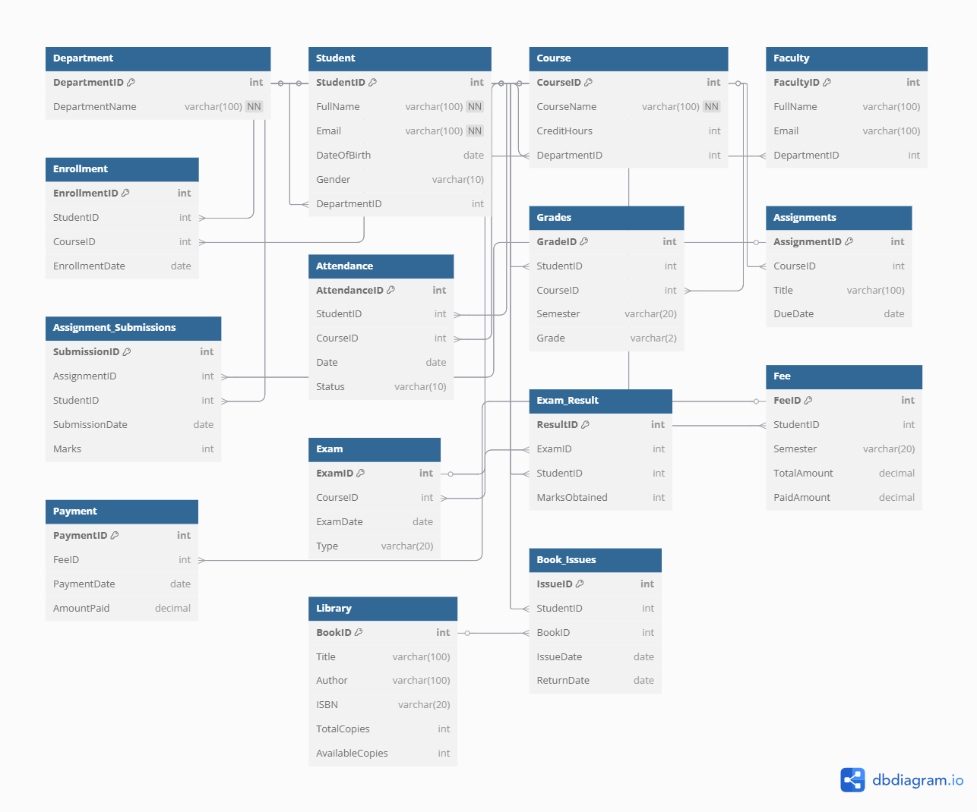

***TRIGGERS:***

1. *Auto update available copies of books*

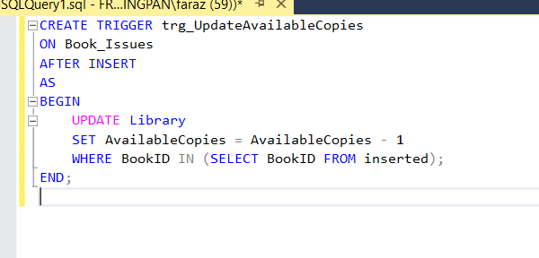

***Description:***

*Automatically decreases the available copies of a book in the Library table when it is issued to a student.*

1. *Auto Update return copies*

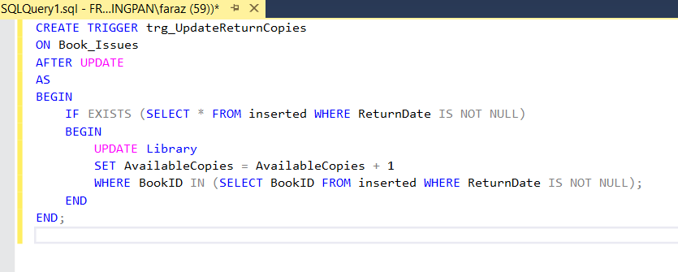

***Description:***

*Automatically increases the available copies in the Library table when a book is returned.*

1. *Prevent Duplicate Enrollment*

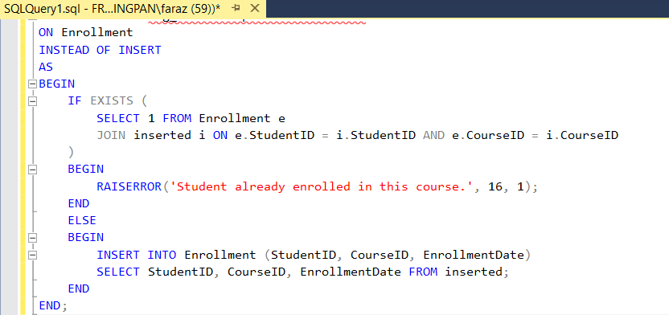

***Description:***

*Prevents a student from being enrolled in the same course more than once by checking for duplicates before insertion.*

1. *Validate Payment*

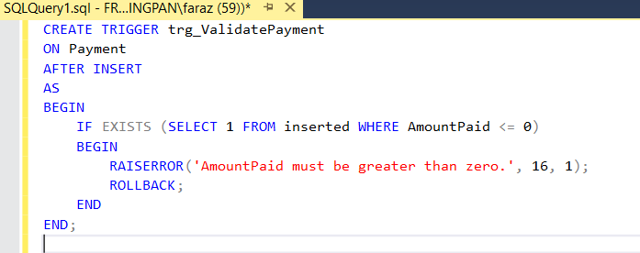

***Description:***

*Ensures that no payment with zero or negative amount is inserted into the payment table.*

***PROCEDURES:***

1. *Get Student Profile*

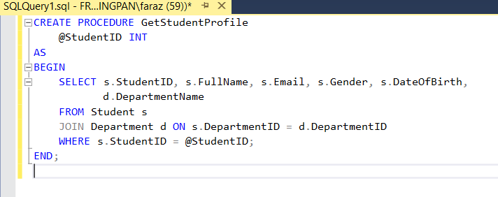

***Description:***

*Retrieves a student's complete profile along with their department name using their StudentID.*

1. *Get Student GPA*

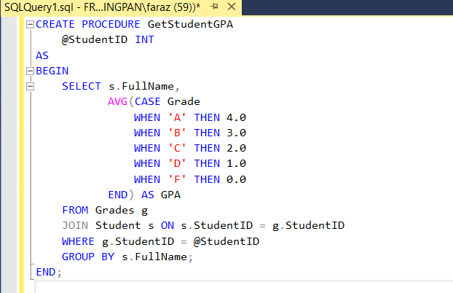

***Description:***

*Calculates and returns the GPA of a student based on letter grades assigned in the Grades table.*

1. *Get Total Fee Paid*

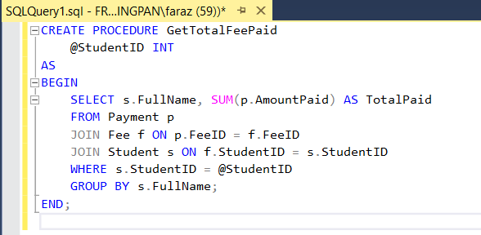

***Description:***

*Returns the total amount of fees paid by a specific student across all semesters.*

1. *Get Student Books*

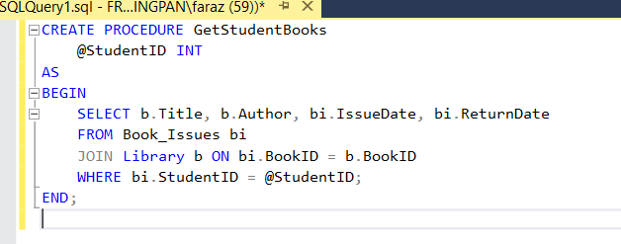

***Description:***

*Lists all books issued to a student, including issue and return dates, based on their StudentID.*

1. *Get Attendance Report*

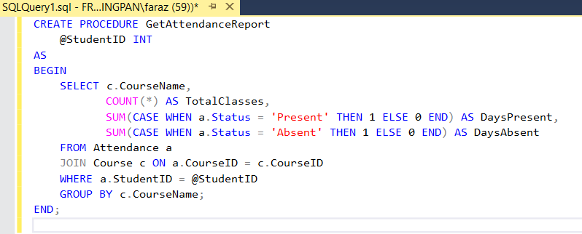

***Description:***

*Shows the number of total classes, days present, and days absent for a student in each course.*

***SCREENSHOTS:***

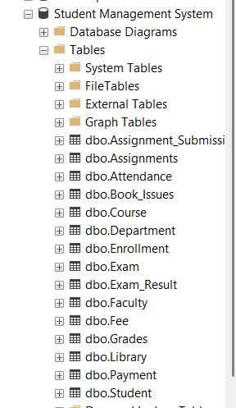

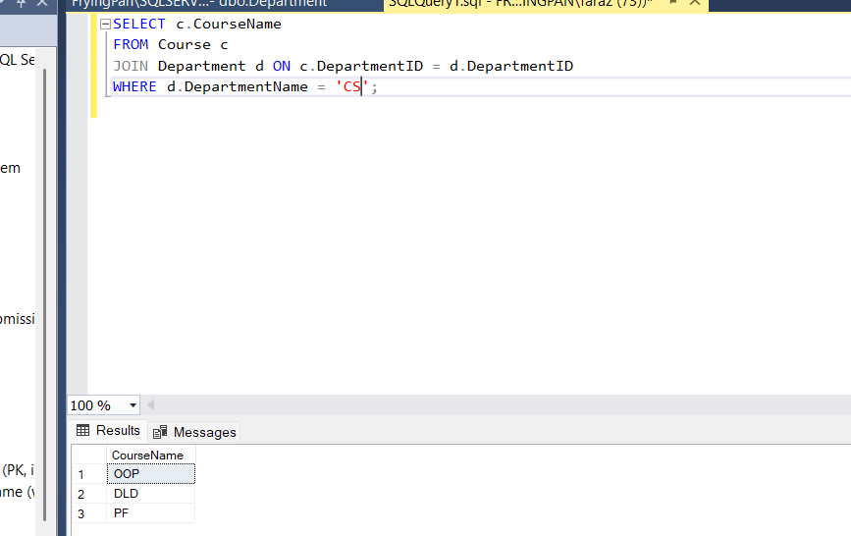

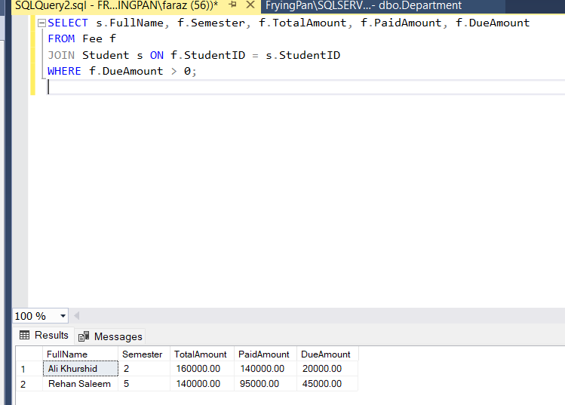

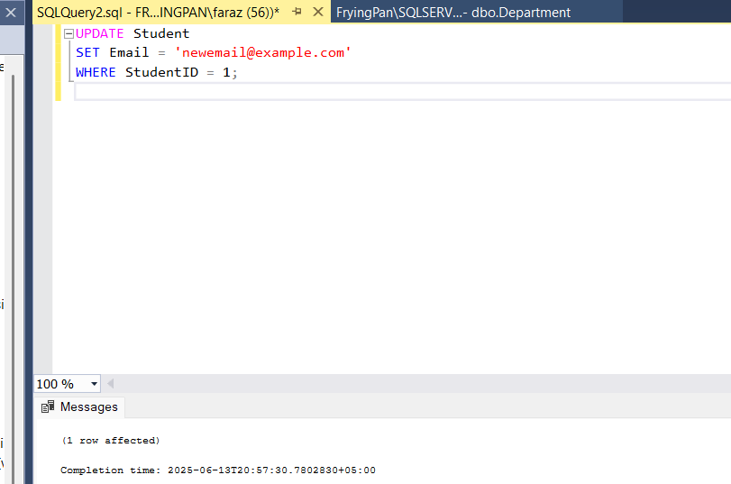

***REFERENCES:***

*Ms. Romana Maroof Lectures*

*Microsoft SQL Server Docs*